- Call to Order:
- Attendance: Is a quorum present?
Geoff Folse - President
Kurt Karlman – Vice President
Mark Sheridan – Treasurer
Theresa Horton - Director
Rob Sladek - Director
Mickie Dion - Director
Brian Walchuk - Director
Nate Griffin
Associa Houston Community Management Services
832-864-1200
NGriffin@houcomm.com

- Visitors
NAME | Discussion Topic(s)

- Agenda
Proposed Changes: |  |  |  |  | Accepted?
Topic | Motion to  Approve: | Second | Aye | Nay |  | Result
- Approval of Minutes for Annual Meeting on 2/21/24
Proposed Changes: |  |  | Accepted?
Motion to Approve | Second | Aye | Nay | Result
- Calendars
  - Review BOD Annual Calendar (Annex A)
  - Review Meeting Calendar for CY2024
Month | Date | Day | Week |  | Month | Date | Day | Week
Jan | 17 | Wed | 3rd |  | Jul | 17 | Wed | 3rd
Feb* | 21 | Wed | 3rd |  | Aug | 21 | Wed | 3rd
Mar | 20 | Wed | 3rd |  | Sep | 18 | Wed | 3rd
Apr | 17 | Wed | 3rd |  | Oct | 16 | Wed | 3rd
May | 15 | Wed | 3rd |  | Nov | 15 | Wed | 3rd
Jun | 19 | Wed | 3rd |  | Dec | 18 | Wed | 3rd
- President’s Report
  - Executive Session Checklist

    - Delinquencies
    - Legal Issues
    - Violations
    - Performance Concerns

- Financial Report from Treasurer
  - Report presentation

  - Outstanding invoices

  - Budget Presentation

    - 2023 Budget status

    - 2024 Budget

- Old Business/New Business
  - ACC – Report (Non-Executive)

  - Action Items - Review/Update Old Actions (action items list).
Assigned | Action | Due Date | Status
Mark | Electrical Contract Renewal – should we renew for 1 year or 5 years | 4/30/24 | Open
Rob S | Evaluate the existing ligustrums and places for new ligustrums, as well as the sprinkler system needs to support.  Have $3500 quote from Bay Area to buy and plant 70 ligustrums.  $45 / plant for ligustrum  Rob S. will get with Theo to count plants that need to be replaced.  Wasting money if replace plants w/out replacing sprinkler system. Sprinkler replacement will be expensive. Recommend waiting until Aug/Sep to replace any plants.  South main header repaired. Drip irrigation installed. More to do in the fall.  Repairs completed along Kirby.  Need to remove dead foliage along Kirby. Look into using funds from TLV. | 5/17/23 | Open
Kurt/Rob S. | Look into sprinkler head protection.  Will install soon. Pipes procured.  Most fixed but new leak at entrance water meter. | 6/21/23 | open
Kelly/Mickie | Get quotes for clubhouse insurance. Still looking at quotes.  Will get quotes from Hinrich Ins Group early next year. (12/20/23)  1/17/24 - Mickie has quote from Hinrichs. Does not include wind and hail. Need to compare to current policy. Will send to BOD for review. | 9/20/23 | Open
Rob S. | Put together action plan to get rid of common areas. | 9/20/23 | open
Nate/Rob S./Geoff | Schedule removal of shrubs and replace fence along Old Kirby from Gate eastward. | 3/20/24 | open

  - Contracts –
    - Pool maintenance contract

    - Landscaping contract
  - Common Areas
    - Clubhouse – Have a rental scheduled on May 26

    - Tennis Courts

    - Sprinkler system status

    - Landscaping -
    - Perimeter Fence

    - Pool Issues –

  - Website

  - New Business

  - Other Topics

- New Actions:
Assigned | Action | Due Date | Status

- Business Meeting Record
Motion to:
Motion to Approve | Second | Aye | Nay | Result

Adjourn Regular Meeting:
Motion | Second | Aye | Nay | Result

  - Proceed to Executive Session.
Adjournment Time:
Motion | Second | Aye | Nay | Result
These Minutes were reviewed and approved by KWPOA BOD.
Date
Annex A: KWPOA BOD Annual Calendar
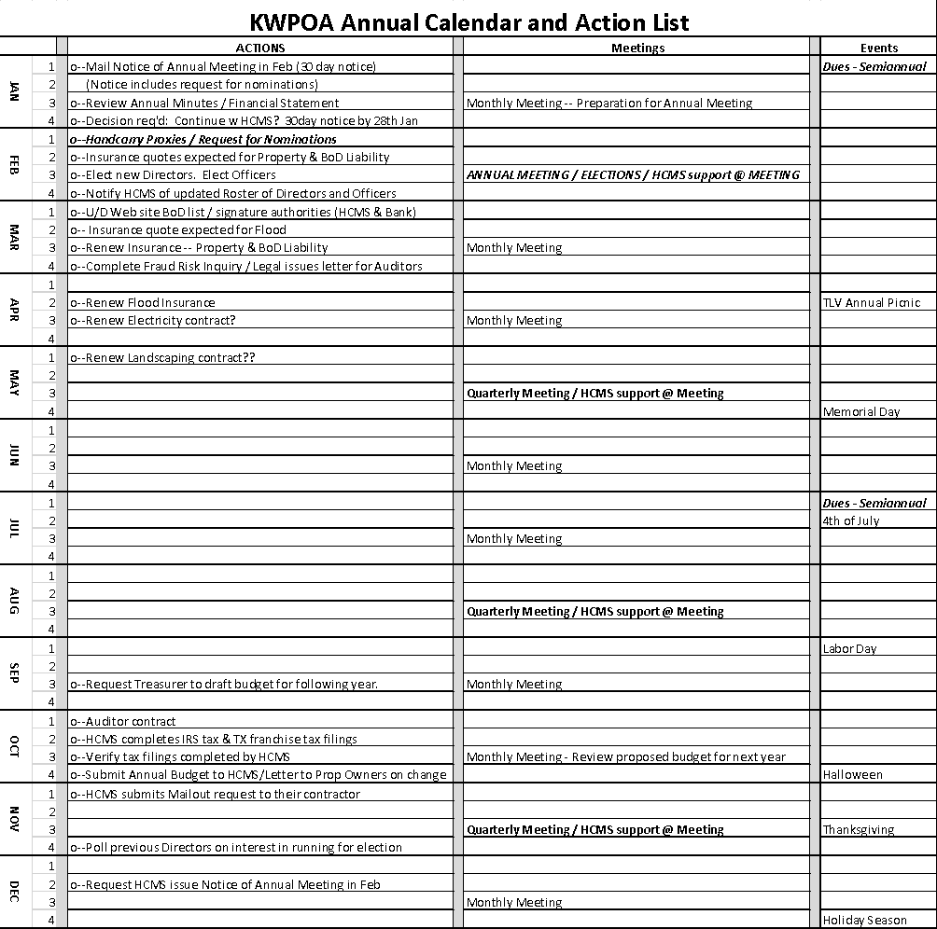

things to work next year (2024)

Geoff  Rob S. | Explore benches for tennis court with resurfacing  Around $1600 / bench. Hi density poly  Will look at other options. Check 2x4basics store on amazon.  Will table until next year. | 4/19/23 | Closed
Rob S/Kurt | Investigate perimeter sprinkler system repair or replace.  Talked to Irrigation Concepts. They want to dig up old one… table this.  Cost prohibitive, will not persue fixing this year. | 6/21/23 | open
